28.35: a) 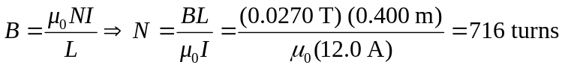
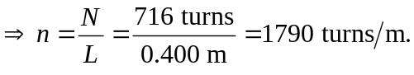
b) The length of wire required is

